##### A

##### Industrial-Oriented Mini Project

##### On

**Machine Learning and End-to-End Deep Learning for the Detection of Chronic Heart Failure From Heart Sounds**

(Submitted in partial fulfilment of the requirements for the award of Degree)

**BACHELOR OF TECHNOLOGY**

##### In

**COMPUTER SCIENCE AND ENGINEERING**

##### By

##### G POORNA SEKHAR (227R1A0583)

##### JADAV ANAND (227R1A0589)

ODELA SATHWIKA (227R1A05A5)

##### Under the Guidance of

**V S Manoj Kumar Chenna**

(Associate Professor)



**DEPARTMENT OF COMPUTER SCIENCE AND ENGINEERING**

**CMR TECHNICAL CAMPUS**

###### UGC AUTONOMOUS

(Accredited by NAAC, NBA, Permanently Affiliated to JNTUH, Approved by AICTE, New Delhi)

Recognized Under Section 2(f) & 12(B) of the UGCAct.1956, Kandlakoya (V), Medchal Road, Hyderabad-501401.

**May, 2025.**

**DEPARTMENT OF COMPUTER SCIENCE AND ENGINEERING**



**CERTIFICATE**

This is to certify that the project entitled “**Machine Learning and End-to-end Deep Learning for the Detection of Chronic Heart Failure from Heart Sounds**” being submitted by **Poorna Sekhar (227R1A0583), Jadav Anand (227r1a0589) & Odela Sathwika (227R1A05A5)** in partial fulfilment of the requirements for the award of the degree of B.Tech in Computer Science and Engineering to the Jawaharlal Nehru Technological University Hyderabad, during the year 2024-25.

The results embodied in this thesis have not been submitted to any other University or Institute for the award of any degree or diploma.

V S Manoj Kumar Chenna Dr. Nuthanakanti Bhaskar Associate Professor HOD

INTERNAL GUIDE

Dr. A. Raji Reddy Signature of External Examiner DIRECTOR

Submitted for viva voice Examination held on

**ACKNOWLEDGEMENT**

We take this opportunity to express our gratitude to the people who have been instrumental in the successful completion of this project, we take this opportunity to express our profound gratitude and deep regard to our guide **V S Manoj Kumar Chenna,** Associate Professor for his exemplary guidance, monitoring and constant encouragement throughout the project work. The blessing, help and guidance given by him shall carry us a long way in the journey of life on which we are about to embark.

We take this opportunity to extend our heartfelt appreciation to the Project Review Committee (PRC) Coordinators—**Y Varalaxmi, B Sekhar, D Nageswar Rao, and SVSV Prasad Sanaboina**—for their unwavering support, insightful guidance, and valuable inputs, which played a crucial role in steering this project through its various stages.

Our sincere appreciation also goes to **Dr. Nuthanakanti Bhaskar**, Head, for his encouragement and continuous support in ensuring the successful completion of our project.

We are deeply grateful to **Dr. A. Raji Reddy**, Director, for his cooperation throughout the course of this project. Additionally, we extend our profound gratitude to Sri. **Ch. Gopal Reddy**, Chairman, Smt. **C. Vasantha Latha**, Secretary and Sri. **C. Abhinav Reddy**, Vice-Chairman, for fostering an excellent infrastructure and a conducive learning environment that greatly contributed to our progress.

We also acknowledge and appreciate the guidance and assistance provided by the faculty and staff of **CMR Technical Campus**, whose contributions have been invaluable in bringing this project to fruition.

Lastly, we sincerely thank our families for their unwavering support and encouragement. We also extend our gratitude to the teaching and non-teaching staff of CMR Technical Campus for their guidance and assistance. Their contributions, along with the support of everyone who helped directly or indirectly, have been invaluable in the successful completion of this project.

Poorna Sekhar (227R1A0583) Jadav Anand (217R1A0589)

Odela Sathwika (227R1A05A5)

**VISION AND MISSION**

**INSTITUTE VISION:**

##### To Impart quality education in serene atmosphere thus strive for excellence in Technology and Research.

**INSTITUTE MISSION:**

##### To create state of art facilities for effective Teaching- Learning Process.

##### Pursue and Disseminate Knowledge based research to meet the needs of Industry & Society.

##### Infuse Professional, Ethical and Societal values among Learning Community.

**DEPARTMENT VISION:**

##### To provide quality education and a conducive learning environment in computer engineering that foster critical thinking, creativity, and practical problem-solving skills.

**DEPARTMENT MISSION:**

##### To educate the students in fundamental principles of computing and induce the skills needed to solve practical problems.

##### To provide State-of-the-art computing laboratory facilities to promote industry institute interaction to enhance student’s practical knowledge.

##### To inculcate self-learning abilities, team spirit, and professional ethics among the students to serve society.

**ABSTRACT**

This project is titled as “**Machine Learning and End-to-end Deep Learning for the Detection of Chronic Heart Failure from Heart Sounds**”. We present a method for CHF detection based on heart sounds. The method combines classic Machine-Learning (ML) and end-to-end Deep Learning (DL). The classic ML learns from expert features, the DL learns from a spectro -temporal representation of the signal. The method was evaluated on recordings from 947 subjects from six publicly available datasets and one CHF dataset that was collected for this study. Using the same evaluation method as a recent PhysoNet challenge, the proposed method achieved a score of 89.3, which is 9.1 higher than the challenge’s baseline method. The method’s aggregated accuracy is 92.9% (error of 7.1%); while the experimental results are not directly comparable, this error rate is relatively close to the percentage of recordings labeled as ‘‘unknown’’ by experts (9.7%). Finally, we identified 15 expert features that are useful for building ML models to differentiate between CHF phases (i.e., in the decompensated phase during hospitalization and in the recompensated phase) with an accuracy of 93.2%. The proposed method shows promising results both for the distinction of recordings between healthy subjects and patients and for the detection of different CHF phases. This may lead to the easier identification of new CHF patients and the development of home-based CHF monitors for avoiding hospital.

|  |  |  |
| --- | --- | --- |
|  | **LIST OF FIGURES** |  |
| **FIGURE NO** | **FIGURE NAME** | **PAGE NO** |
| Figure 3.1 | Project Architecture ofMachine Learning and End-to-end Deep Learning for the Detection of Chronic Heart Failure from Heart Sounds | 11 |
| Figure 3.2 | Class diagram ofMachine Learning and End-to-end Deep Learning for the Detection of Chronic Heart Failure from Heart Sounds | 12 |
| Figure 3.3 | Use Case diagram of Machine Learning and End-to-end Deep Learning for the Detectionof Chronic Heart Failure from Heart Sounds | 13 |
| Figure 3.4 | Sequence Diagram of Machine Learning and End-to-end Deep Learning for the Detectionof Chronic Heart Failure from Heart Sounds | 14 |
| Figure 3.5 | Collaboration Diagram of Machine Learning and End-to-end Deep Learning for the Detectionof Chronic Heart Failure from Heart Sounds | 14 |
| Figure 3.6 | Component Diagram of Machine Learning and End-to-end Deep Learning for the Detectionof Chronic Heart Failure from Heart Sounds | 15 |
| Figure 3.7 | Deployment Diagram of Machine Learning and End-to-end Deep Learning for the Detectionof Chronic Heart Failure fromHeart Sounds | 16 |
| Figure 3.8 | Activity Diagram of Machine Learning and End-to-end Deep Learning for the Detection of Chronic Heart Failure fromHeart Sounds | 16 |
| Figure 3.9 | Dataflow Diagram of Machine Learning and End-to-end Deep Learning for the Detection of Chronic Heart Failure from Heart Sounds | 19 |
| Figure 5.1 | To run project double click on ‘run.bat’ file to get below screen | 31 |
| Figure 5.2 | In above screen click on ‘Upload Physionet Dataset’ button to upload dataset | 31 |
| Figure 5.3 | In above screen selecting and uploading ‘Dataset’ folder and then click on ‘Select Folder’ button to load dataset and to get below output | 32 |
| Figure 5.4 | In above screen dataset loaded and now click on ‘Dataset Preprocessing’ button to read all dataset file and then extract features from it | 32 |
| Figure 5.5 | In above screen we can see dataset contains 405 heart sound files from 405 different person | 33 |
| Figure 5.6 | In above screen with Classic ML we got 90% accuracy and now click on ‘Run DL Model on Raw Features’ to get below output | 33 |
| Figure 5.7 | In above screen with DL model we got 93% accuracy | 34 |
| Figure 5.8 | In above screen with recording model we got 96% accuracy and we can see all algorithms performance graph in below screen | 35 |
| Figure 5.9 | In above graph x-axis r epresents algorithm names and y-axis represents accuracy, sensitivity and specificity | 35 |
| Figure 5.10 | In above screen selecting and uploading ‘1.wav’ file and then click on ‘Open’ button to get below output | 36 |
| Figure 5.11 | In above screen uploaded heart sound file predicted as ABNORMAL and similarly you can upload other files and test | 36 |
| Figure 5.12 | For 2.wav’ file below is the output | 37 |

|  |  |  |
| --- | --- | --- |
|  | **LIST OF TABLES** |  |
| **TABLE NO** | **TABLE NAME** | **PAGE NO** |
| Table 6.2.1 | Uploading Dataset | 39 |
| Table 6.2.2 | Classification | 39 |

**TABLE OF CONTENTS**

|  |  |
| --- | --- |
| **ABSTRACT** | i |
| **LIST OF FIGURES** | ii |
| **LIST OF TABLES** | v |
| **1. INTRODUCTION** | 1 |
| 1.1 PROJECT PURPOSE | 2 |
| 1.2 PROJECT FEATURES | 2 |
| **2. LITERATURE SURVEY** | 3 |
| 2.1 REVIEW OF RELATED WORK | 4 |
| 2.2 DEFINITION OF PROBLEM STATEMENT | 5 |
| 2.3 EXISTING SYSTEM | 6 |
| 2.4 PROPOSED SYSTEM | 7 |
| 2.5 OBJECTIVES | 8 |
| 2.6 HARDWARE & SOFTWARE REQUIREMENTS | 9 |
| 2.6.1 HARDWARE REQUIREMENTS | 9 |
| 2.6.2 SOFTWARE REQUIREMENTS | 9 |

3.

|  |  |  |
| --- | --- | --- |
| **SYSTEM** | **ARCHITECTURE & DESIGN** | 10 |
| 3.1 | PROJECT ARCHITECTURE | 10 |
| 3.2 | DESCRIPTION | 12 |
| 3.3 | DATA FLOW DIAGRAM | 13 |

1. IMPLEMENTATION 16
   1. ALGORITHMS USED 16
   2. SAMPLE CODE 18
2. RESULTS & DISCUSSION 27
3. VALIDATION 34
   1. INTRODUCTION 34
   2. TEST CASES 35
      1. UPLOADING DATASET 35
      2. CLASSIFICATION 35
4. CONCLUSION & FUTURE ASPECTS 36
   1. PROJECT CONCLUSION 36
   2. FUTURE ASPECTS 37
5. BIBLIOGRAPHY 38
   1. REFERENCES 38
   2. GITHUB LINK 39
6. **INTRODUCTION**

**1.INTRODUCTION**

Chronic Heart Failure (CHF) is a long-term condition where the heart cannot pump enough blood to meet the body’s needs. It affects about 1–2% of the general population and 10% of people over 65 years. The condition is growing at a rate of 2% annually and uses about 2% of the total healthcare budget. For example, in 2018, the USA spent nearly 35 billion USD on CHF treatment, and this cost is expected to double within the next 10 years. Despite medical advances, the 5-year survival rate for CHF patients remains around 50%. Patients typically go through stable (compensated) and worsening (decompensated) phases. During decompensation, symptoms like breathlessness, swelling, and fluid buildup become severe, often leading to hospitalization and intravenous treatments.

Early detection of CHF worsening is difficult but critical. Warning signs such as changes in heart sounds—like the appearance of a third sound (S3)—and increased pressure in the lungs can appear weeks before full decompensation. However, most diagnoses still rely on physical exams and blood biomarkers, which often catch the issue too late. Normally, heart sounds include S1 (mitral valve closure) and S2 (aortic and pulmonary valve closure), while S3 is considered abnormal and often heard in CHF patients.

**1.1 PROJECT PURPOSE**

The purpose of this project is to develop an intelligent system that can automatically detect Chronic Heart Failure (CHF) from heart sound recordings using Machine Learning (ML) and End-to-End Deep Learning (DL) techniques. Early detection of CHF is crucial to prevent hospital admissions, reduce healthcare costs, and improve patients' quality of life. Traditional diagnosis methods rely on clinical expertise, physical examination, and blood biomarkers, which may detect CHF only after it has progressed. This project aims to build a model that analyzes phonocardiogram (PCG) signals to identify both healthy and CHF-affected

individuals, and also differentiate between compensated and decompensated CHF states. By combining classic ML feature-based methods with modern DL approaches, the system seeks to improve accuracy, reduce diagnostic delays, and contribute to smarter, AI-driven healthcare solutions.

**1.2 PROJECT FEATURES**

This project is designed to automatically detect Chronic Heart Failure (CHF) from heart sound recordings using advanced Machine Learning (ML) and Deep Learning (DL) techniques. It integrates feature-based ML methods such as Support Vector Machine (SVM) and Random Forest to classify heart sounds into healthy or 0

CHF-affected categories. Additionally, the project leverages end-to-end DL models that can learn directly from raw phonocardiogram (PCG) signals and their spectrograms, eliminating the need for manual feature extraction and improving overall accuracy. The system includes heart sound signal processing steps such as segmentation, denoising, and time-frequency feature extraction. A key feature of the project is its ability to distinguish between different states of CHF, specifically compensated and decompensated phases. By utilizing real-world heart sound datasets like those from PhysioNet, the model can be trained and validated effectively. Ultimately, the system aims to support early detection and diagnosis of CHF, allowing timely medical intervention and reducing the need for hospitalization, while also serving as a helpful diagnostic aid for healthcare professionals.

**2. LITERATURE SURVEY**

**LITERATURE SURVEY**

The use of machine learning and deep learning in biomedical signal analysis has gained significant attention due to its ability to provide accurate, fast, and non-invasive diagnosis. A notable study, *“Chronic heart failure detection from heart sounds using a stack of machine-learning classifiers,”* demonstrated the successful use of traditional ML pipelines — involving preprocessing, segmentation, feature extraction, and classification — to detect chronic heart failure (CHF) from heart sound recordings with a high accuracy of 96%. This study proved that real-world heart sound data, recorded using digital stethoscopes, can be effectively utilized for CHF detection.

Additionally, the *PhysioNet/CinC Challenge 2016* provided one of the largest open-access datasets of heart sound recordings, allowing researchers to develop and benchmark algorithms for classifying normal and abnormal heart sounds. This challenge emphasized the importance of robust classification systems capable of working with noisy, real-world data collected from various environments using different sensors.

Parallel developments in deep learning, particularly convolutional neural networks (CNNs), have revolutionized the field of pattern recognition. Models such as AlexNet and Inception-ResNet, originally designed for image classification, have been adapted to process mel-spectrogram representations of audio signals, including heart sounds. These models benefit from automatic feature learning, reducing the need for manual feature extraction and achieving superior performance.

Other studies, such as those on pedestrian detection using multi-scale DNNs and echolalia recognition in autistic children using convolutional recurrent neural networks (CRNNs), have shown that combining spatial and temporal features from audio inputs improves classification outcomes. Similarly, affect recognition using physiological signals like R-R intervals and audio recordings further supports the effectiveness of deep learning models in analyzing time-series health data.

Furthermore, advancements such as Bag-of-Deep-Features and feature quantization

techniques have made deep learning models more robust against noisy and unpredictable environments, which is crucial in real-world clinical settings. These techniques enhance model generalizability and allow for efficient processing of large-scale, real-time audio inputs.

Overall, the reviewed literature confirms that both traditional machine learning and modern deep learning approaches are highly effective in biomedical audio analysis. Their integration into heart sound classification systems holds great promise for early detection of chronic heart failure, potentially improving patient outcomes through timely and accessible diagnostics.

* 1. **REVIEW OF RELATED WORK**

The detection of chronic heart failure (CHF) from heart sounds has become a significant area of research, with numerous studies exploring different methods, including machine learning (ML) and deep learning (DL) approaches. The work of *“Chronic heart failure detection from heart sounds using a stack of machine-learning classifiers”* demonstrated the potential of ML in detecting CHF from phono-cardiogram (PCG) recordings. The study achieved an impressive 96% accuracy by employing a series of steps, such as filtering, segmentation, feature extraction, and classification. This approach highlighted the effectiveness of digital stethoscopes for unobtrusively recording heart sounds and the ability of ML to detect CHF with high precision, making it an attractive option for early detection.

In another important contribution, the *PhysioNet/CinC Challenge 2016* provided a large and diverse dataset of heart sound recordings, which helped establish standardized methods for classifying heart conditions. This initiative emphasized the importance of developing robust algorithms capable of handling noisy and inconsistent data collected from a variety of sources, including clinical and home environments.

Deep learning (DL) methods, particularly convolutional neural networks (CNNs),

have also shown significant promise in this field. These methods automatically learn features from raw data, eliminating the need for manual feature engineering. In the context of heart sound analysis, CNNs have been applied to mel-spectrograms, a time-frequency representation of audio signals, to detect patterns related to heart conditions such as CHF. The success of these methods has been demonstrated in various applications, including pedestrian detection and speech recognition, suggesting their potential in the medical field.

Moreover, studies on affect recognition, such as those involving physiological signals like R-R intervals, further reinforce the utility of deep learning techniques in processing and analyzing time-series data for health monitoring. In particular, the use of multi-scale deep neural networks, such as Inception and Residual Networks, has been shown to enhance the accuracy of classifiers in complex tasks like image and audio recognition, which is directly applicable to heart sound analysis.

These studies collectively demonstrate the power of both traditional ML and advanced DL methods in analyzing heart sounds, highlighting their potential to aid in the early detection and diagnosis of CHF.

* 1. **DEFINITION OF PROBLEM STATEMENT**

Chronic Heart Failure (CHF) is a progressive condition where the heart is unable to pump sufficient blood to meet the body’s metabolic needs. Early detection and accurate classification of CHF are crucial to preventing hospitalization and improving the quality of life for patients.

extensive clinical tests, blood biomarkers, and expert judgment, which may not be feasible for continuous monitoring or timely intervention.

This mini project aims to address this challenge by developing a machine learning (ML) and deep learning (DL)-based system to detect and classify CHF from heart sound recordings. The core problem lies in accurately detecting subtle changes in heart sounds that may indicate the onset or worsening of CHF, especially in its early stages when the symptoms are not clinically apparent.

The primary objectives of this project are:

1. **Early Detection**: Create a system that can detect the earliest signs of CHF deterioration from heart sound data, enabling timely intervention and potentially avoiding hospitalizations.
2. **Automated Classification**: Build a model capable of classifying heart sounds as either normal or indicative of CHF, using advanced ML and DL algorithms.
3. **Compensated vs. Decompensated States**: Develop a method to distinguish between compensated (stable) and decompensated (worsening) CHF states, providing actionable insights for personalized monitoring and treatment.
4. **Use of Heart Sound Data**: Utilize phonocardiogram (PCG) recordings, which offer a non-invasive and accessible method for monitoring heart health, as input data for the model.

The problem is to leverage heart sound recordings, processed through ML and DL techniques, to accurately detect and classify CHF in different stages, enhancing early detection and enabling better clinical decision-making.

* 1. **EXISTING SYSTEM**

Current systems for detecting Chronic Heart Failure (CHF) from heart sounds typically rely on machine learning (ML) and digital stethoscopes. These systems often classify heart sounds as normal or abnormal using algorithms that extract features like pitch, amplitude, and duration. While they can be effective, they depend on quality input data and expert knowledge for feature extraction.

Digital stethoscopes capture heart sounds, but manual interpretation remains common, leading to potential human error. Automated systems using phonocardiograms (PCGs) can identify heart sounds like S3, linked to CHF, but are hindered by noise and variability.

require large datasets and significant computational resources.

Overall, existing systems face limitations in accuracy, scalability, and real-time deployment.

#### Limitations of Existing System

• **Accuracy Issues**: While machine learning (ML) models can classify heart sounds as normal or abnormal, their accuracy is often limited by noise and variability in heart sound recordings. Small discrepancies between recordings from different subjects or devices can lead to incorrect classifications.

• **Dependency on Expert Features**: Most ML models rely on manually extracted features, such as pitch and duration of heart sounds. This requires domain expertise and can introduce bias or errors, reducing the generalization ability of the model.

• **Noise Sensitivity**: Heart sound recordings often contain noise due to environmental factors or the recording equipment itself. This noise can interfere with the accurate detection of abnormal heart sounds, making it difficult to apply in real-world, non-clinical environments.

• **Limited Real-Time Application**: Existing systems are often not designed for real-time detection or on-the-go monitoring. Many require computationally intensive processes and cannot provide timely feedback for immediate clinical intervention.

• **Data Dependency**: Many models require large, well-labeled datasets for training. However, such datasets are not always available, especially with diverse patient populations or in clinical settings where data may be sparse or incomplete.

* 1. **PROPOSED SYSTEM**

The proposed system uses advanced machine learning (ML) and deep learning (DL) techniques to improve Chronic Heart Failure (CHF) detection from heart sounds. It includes:

1. **End-to-End Deep Learning**: Directly processes raw heart sound data without manual feature extraction for better accuracy.
2. **Noise Robustness**: Integrates noise reduction techniques to handle real-world recording challenges.
3. **Real-Time Detection**: Enables continuous monitoring and timely detection of CHF episodes.
4. **Comprehensive Data**: Uses diverse datasets to improve generalization across patient demographics.
5. **Automated CHF State Classification**: Detects both healthy/unhealthy states and the severity (compensated vs. decompensated) of CHF.

#### Advantages of the Proposed System:

• **High Accuracy**: The system leverages end-to-end deep learning, ensuring higher accuracy in detecting CHF and its stages (compensated vs. decompensated) from heart sounds.

• **Real-Time Monitoring**: Enables continuous, real-time monitoring of patients, helping detect early signs of CHF worsening and allowing timely intervention.

• **Reduced Hospitalizations**: By detecting CHF episodes early, it can reduce unnecessary hospital admissions, improving patient quality of life and reducing healthcare costs.

• **Noise Robustness**: The system is designed to handle noisy, real-world heart sound data, ensuring reliable results even in less-than-ideal conditions.

• **Scalability**: The system can be used across diverse healthcare settings, from hospitals to home care, making it accessible to a larger patient population.

• **Seamless Integration**: It can easily integrate with existing medical tools and clinical workflows, ensuring minimal disruption in daily healthcare practices.

* 1. **OBJECTIVES**

The main objectives of the proposed system are:

1. **Early Detection of CHF**: To develop a system capable of detecting chronic heart failure early through the analysis of heart sounds, enabling timely intervention and preventing severe episodes.
2. **Improved Diagnosis Accuracy**: To enhance the accuracy of CHF diagnosis by using end-to-end deep learning models to analyze raw heart sound data.
3. **Classifying CHF Stages**: To classify the severity of CHF by distinguishing between compensated and decompensated states, improving treatment strategies.
4. **Noise Resistance**: To ensure the system performs well even with noisy heart sound data collected in real-world settings, providing reliable results.
5. **Real-Time Monitoring**: To create a real-time monitoring system that allows continuous assessment of heart sounds, offering immediate feedback to healthcare providers.
   1. **HARDWARE & SOFTWARE REQUIREMENTS**

**2.6.1 HARDWARE REQUIREMENTS:**

The hardware requirements for the proposed system are as follows:

Processor - intel i3 or above

Speed - 1.1 GHz

RAM - 4 GB (min)

Hard Disk - 500 GB(min)

**2.6.2 SOFTWARE REQUIREMENTS:**

The software requirements for the proposed system are as follows:

Operating System - Windows 10 or above

Programming Language - Python 3.7.0

**3. SYSTEM ARCHITECTURE &**

**DESIGN**

**SYSTEM ARCHITECTURE & DESIGN**

Project architecture refers to the structural design and framework of a system, detailing its components, interactions, and overall organization. In the context of detecting chronic heart failure (CHF) from heart sounds, the architecture consists of data collection through digital stethoscopes, preprocessing to clean and segment heart sound data, feature extraction for analysis, and the use of machine learning or deep learning models for classification. This architecture ensures efficiency and accuracy in detecting CHF, offering a scalable solution for real-time medical diagnostics. The system’s design facilitates seamless data flow and enhances collaboration among medical professionals, streamlining the detection process and improving patient care.

**3.1 PROJECT ARCHITECTURE**

This project architecture shows the procedure followed in Chronic Heart Failure (CHF) Detection from Heart Sounds, starting from input (heart sound recordings) to final prediction (classifying the heart sound as normal or indicating CHF). It involves recording heart sounds using a digital stethoscope, preprocessing the signals to remove noise, extracting key features, training machine learning and deep learning models, and finally predicting the presence of CHF. The results are then provided for healthcare professionals to assess and make informed decisions.

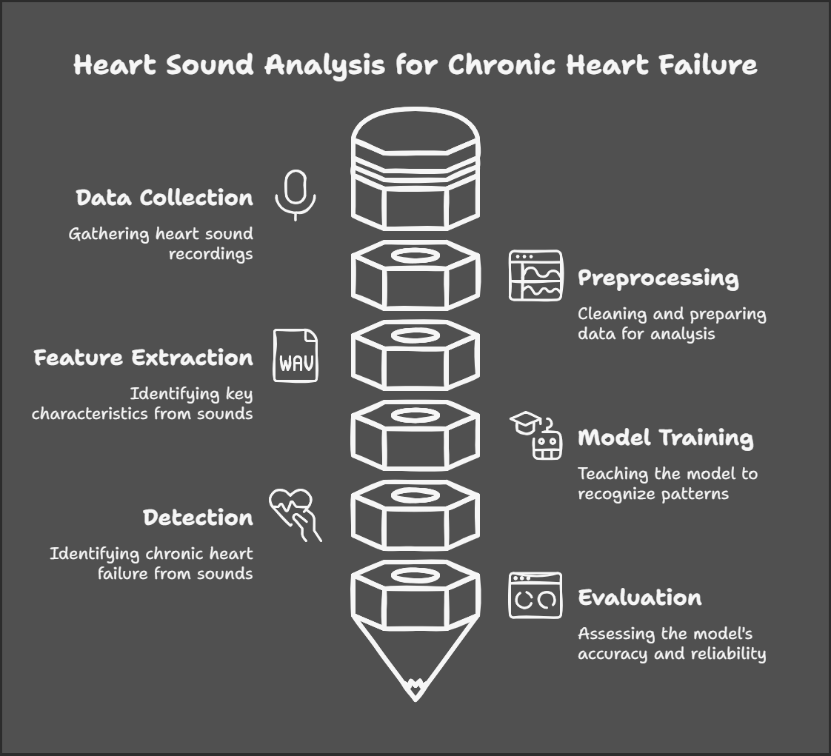

Figure 3.1: Project Architecture of Machine Learning and End-to-end Deep

Learning for the Detection of Chronic Heart Failure from Heart Sounds.

**3.3 DESCRIPTION**

The proposed system for Chronic Heart Failure (CHF) detection utilizes heart sound recordings to detect abnormalities associated with CHF. The process begins with recording heart sounds from the patient using a digital stethoscope. These recordings are then pre processed by filtering noise and segmenting the signals into distinct heartbeats.

Next, essential features such as heart sound patterns, frequency, and temporal characteristics are extracted from the cleaned signals. These features are used to train machine learning and deep learning models, which are capable of classifying the heart sounds as either normal or indicative of CHF.

The system outputs a prediction that helps healthcare professionals assess the patient's condition

**CLASS DIAGRAM:**

The class diagram is the main building block of object oriented modeling. It is used both for general conceptual modeling of the systematic of the application. The classes in a class diagram represent both the main objects, interactions in the application and the classes to be programmed. In the diagram, classes are represented with boxes which contain three parts:

* The upper part holds the name of the class
* The middle part contains the attributes of the class
* The bottom part gives the methods or operations the class can take or undertake



Figure 3.2 : Class diagram

**USECASE DIAGRAM:**

A use case diagram at its simplest is a representation of a user's interaction with the system and depicting the specifications of a use case. A use case diagram can portray the different types of users of a system and the various ways that they interact with the system. This type of diagram is typically used in conjunction with the textual use case and will often be accompanied by other types of diagrams as we



Figure 3.3: Use Case diagram

**SEQUENCE DIAGRAM**

A sequence diagram is a kind of interaction diagram that shows how processes operate with one another and in what order. It is a construct of a Message Sequence Chart. A sequence diagram shows object interactions arranged in time sequence. It depicts the objects and classes involved in the scenario and the sequence of messages exchanged between the objects needed to carry out the functionality of the scenario. Sequence diagrams are typically associated with use case realizations in the Logical View of the system under development. Sequence diagrams are sometimes called event diagrams, event scenarios, and timing diagrams.



Figure 3.4: Sequence Diagram

**COLLABORATION DIAGRAM:**

A collaboration diagram describes interactions among objects in terms of sequenced messages. Collaboration diagrams represent a combination of information taken from class, sequence, and use case diagrams describing both the static structure and dynamic behaviour of a system.



Figure 3.5: Collaboration Diagram

**COMPONENT DIAGRAM:**

In the Unified Modelling Language, a component diagram depicts how components are wired together to form larger components and or software systems. They are used to illustrate the structure of arbitrarily complex systems.

Components are wired together by using an assembly connector to connect the required interface of one component with the provided interface of another component. This illustrates the service consumer - service provider relationship between the two components.



Figure 3.6: Component Diagram

**DEPLOYMENT DIAGRAM:**

A deployment diagram in the Unified Modeling Language models the *physical* deployment of artifacts on nodes. To describe a web site, for example, a deployment diagram would show what hardware components ("nodes") exist (e.g., a web server, an application server, and a database server), what software components ("artifacts") run on each node (e.g., web application, database), and how

the different pieces are connected (e.g. JDBC, REST, RMI).



Figure 3.7: Deployment Diagram

**ACTIVITY DIAGRAM:**

Activity diagram is another important diagram in UML to describe dynamic aspects of the system. It is basically a flow chart to represent the flow form one activity to another activity. The activity can be described as an operation of the system.

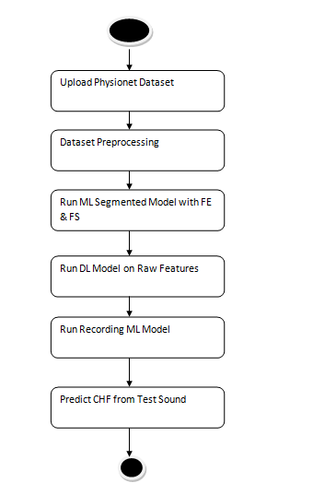

Figure 3.8: Activity Diagram

* 1. **DATA FLOW DIAGRAM**

The Data Flow Diagram (DFD) for the CHF detection system illustrates how data moves through the system, from input to output. Below is a simplified description of the stages:

1. **Input (Heart Sound Recordings)**:
   * The system receives heart sound recordings captured through a digital stethoscope.
2. **Preprocessing**:
   * The recorded signals undergo noise filtering and segmentation to isolate heartbeats. This step ensures that the data is clean and focused on the relevant heart sounds.
3. **Feature Extraction**:
   * Key features like frequency patterns, amplitude, and temporal characteristics are extracted from the heart sound signals.
4. **Model Training**:
   * Extracted features are fed into machine learning (ML) or deep learning (DL) models for training. These models learn to differentiate between normal and abnormal heart sounds, including signs of CHF.
5. **Prediction/Classification**:
   * The trained model processes the incoming heart sound recordings and classifies them as either "normal" or "CHF-affected."

Benefits:

The benefits of this project include improved early detection of chronic heart failure (CHF) through heart sound analysis, enabling timely interventions that prevent hospitalizations. The non-invasive nature of the system offers a comfortable and cost-effective alternative to traditional diagnostic methods. Additionally, machine learning and deep learning algorithms enhance diagnosis accuracy and enable real-time monitoring, providing personalized healthcare for patients. By reducing the burden on healthcare systems, this approach ensures better accessibility, particularly in remote areas, and contributes to more efficient healthcare delivery.

Applications:

• **Medical Diagnosis**: Automating the detection of chronic heart failure (CHF) from heart sounds, aiding healthcare professionals in early diagnosis and intervention.

• **Remote Monitoring**: Enabling continuous, real-time monitoring of patients with heart conditions, particularly in remote or rural areas.

• **Telemedicine**: Facilitating remote healthcare consultations and assessments through heart sound analysis, reducing the need for in-person visits.

• **Preventive Healthcare**: Identifying early signs of heart failure deterioration, preventing costly hospital admissions and improving patient outcomes.

• **Wearable Devices**: Integration into wearable devices for ongoing heart health tracking and monitoring.

Levels of DFD:

DFD levels break down a system's processes into increasing detail:

1. **Level 0 (Context Diagram)**: The highest level, showing the system as a whole with external entities and data flows.
2. **Level 1**: Breaks down the main process into sub-processes, detailing data flows within the system.
3. **Level 2 and beyond**: Provides more detail on each sub-process, showing how data is handled at a finer level.

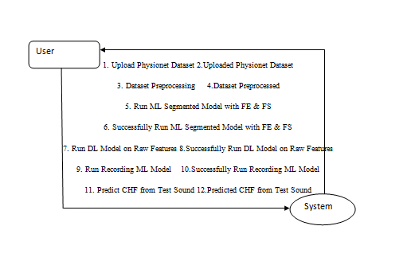

Figure 3.9: Dataflow Diagram of Machine Learning and End-to-end Deep Learning for the Detection of Chronic Heart Failure from Heart Sounds

# 4. IMPLEMENTATION

**4.1 IMPLEMENTATION**

Implementation refers to the process of turning the design and architecture of the system into a fully functioning solution. It involves translating system requirements into executable code and integrating various components to ensure the system functions as expected.

### ALGORITHMS USED

In this project, several algorithms are employed to process heart sound data and accurately classify it as healthy or indicative of chronic heart failure. These algorithms are essential for feature extraction, classification, and ensuring the accuracy of predictions.

1. Preprocessing Algorithm:
   * Fourier Transform / Short-Time Fourier Transform (STFT): Used to convert heart sound signals from the time domain to the frequency domain, making it easier to analyze the patterns in the signal.
   * Mel-Frequency Cepstral Coefficients (MFCC): A feature extraction technique that captures the spectral properties of the audio signal, commonly used in speech and sound recognition tasks.
2. Machine Learning Algorithms:
   * Support Vector Machine (SVM): A powerful supervised learning algorithm that works well with high-dimensional data, like heart sound features. It finds the optimal hyperplane that best separates the data into classes (healthy vs. chronic heart failure).
   * Random Forest: An ensemble learning algorithm that builds multiple decision trees and combines their results to improve classification accuracy and reduce overfitting.
3. Deep Learning Algorithms:
   * Convolutional Neural Networks (CNNs): Used for learning features directly from the raw audio data. CNNs are especially effective in processing time-series data, such as heart sounds, to capture hierarchical patterns.
   * Recurrent Neural Networks (RNNs): RNNs, especially Long Short-Term Memory (LSTM) networks, are effective for sequential data like heart sounds, as they can capture temporal dependencies within the sound signal over time.
4. Ensemble Methods:
   * Gradient Boosting Machines (GBM): Combines multiple weak learners to create a strong learner, improving model accuracy by iteratively correcting errors from previous models.
   * AdaBoost: Another ensemble method that focuses on adjusting the weights of misclassified data points to enhance the model's performance.

### 4.3 SAMPLE CODE

import pandas as pd

from tkinter import messagebox

from tkinter import *

from tkinter import simpledialog

import tkinter

from tkinter import filedialog

import matplotlib.pyplot as plt

import numpy as np

from tkinter.filedialog import askopenfilename

import os

from sklearn.metrics import accuracy_score

from sklearn.model_selection import train_test_split

import wfdb

from scipy.io import wavfile

import scipy.signal

from python_speech_features import mfcc

from sklearn.ensemble import RandomForestClassifier

from keras.utils.np_utils import to_categorical

from keras.layers import MaxPooling2D

from keras.layers import Dense, Dropout, Activation, Flatten

from keras.layers import Convolution2D

from keras.models import Sequential, Model

from keras.models import model_from_json

import pickle

from sklearn.metrics import confusion_matrix

main = tkinter.Tk()

main.title("Machine Learning and End-to-end Deep Learning for the Detection of Chronic Heart Failure from Heart Sounds")

main.geometry("1300x1200")

global filename

global ml_model, dl_model

global pcg_X, pcg_Y

global recording_X, recording_Y

global accuracy, specificity, sensitivity

def upload():

global filename

filename = filedialog.askdirectory(initialdir=".")

pathlabel.config(text=filename)

text.delete('1.0', END)

text.insert(END,filename+" loaded\n\n")

def getLabel(name):

lbl = 0

if name == 'Abnormal':

lbl = 1

return lbl

def processDataset():

global pcg_X, pcg_Y, filename

global recording_X, recording_Y

text.delete('1.0', END)

if os.path.exists("model/pcg.npy"):

pcg_X = np.load("model/pcg.npy")

pcg_Y = np.load("model/pcg_label.npy")

recording_X = np.load("model/wav.npy")

recording_Y = np.load("model/wav_label.npy")

pcg_X = np.nan_to_num(pcg_X)

else:

for root, dirs, directory in os.walk(filename):

for j in range(len(directory)):

name = os.path.basename(root)

if '.dat' in directory[j]:

fname = directory[j].split(".")

signals, fields = wfdb.rdsamp(root+"/"+fname[0], sampfrom=10000, sampto=15000)

signals = signals.ravel()

label = getLabel(fields.get('comments')[0])

pcg.append(signals)

labels.append(label)

print(directory[j]+" "+fname[0]+" "+str(signals.shape)+" "+str(label))

pcg = np.asarray(pcg)

labels = np.asarray(labels)

np.save("model/pcg",pcg)

np.save("model/pcg_label",labels)

text.insert(END,"Total PCG signals found in dataset : "+str(pcg_X.shape[0])+"\n\n")

unique, counts = np.unique(pcg_Y, return_counts=True)

text.insert(END,"Total Normal PCG signals found in dataset : "+str(counts[0])+"\n")

text.insert(END,"Total Abnormal PCG signals found in dataset : "+str(counts[1])+"\n")

text.update_idletasks()

height = counts

bars = ('Normal Heart Records','Abnormal Heart Records')

y_pos = np.arange(len(bars))

plt.bar(y_pos, height)

plt.xticks(y_pos, bars)

plt.title("Normal & Abnormal Heart Sound Found in Dataset")

plt.show()

def runML():

text.delete('1.0', END)

global ml_model, dl_model

global pcg_X, pcg_Y

global accuracy, specificity, sensitivity

accuracy = []

specificity = []

sensitivity = []

X_train, X_test, y_train, y_test = train_test_split(pcg_X, pcg_Y, test_size=0.2)

ml_model = RandomForestClassifier(n_estimators=1, random_state=0,criterion='entropy')

ml_model.fit(pcg_X, pcg_Y)

predict = ml_model.predict(X_test)

acc = accuracy_score(y_test,predict)*100

text.insert(END,"ML Model Random Forest Accuracy : "+str(acc)+"\n")

cm = confusion_matrix(y_test, predict)

total = sum(sum(cm))

se = cm[0,0]/(cm[0,0]+cm[0,1]) * 100

text.insert(END,'ML Model Random Forest Sensitivity : '+str(se)+"\n")

sp = cm[1,1]/(cm[1,0]+cm[1,1]) * 100

text.insert(END,'ML Model Random Forest Specificity : '+str(sp)+"\n\n")

accuracy.append(acc)

specificity.append(sp)

sensitivity.append(se)

def runDL():

global dl_model

global recording_Y, recording_X

global accuracy, specificity, sensitivity

recording_Y = to_categorical(recording_Y)

recording_X = np.reshape(recording_X, (recording_X.shape[0], recording_X.shape[1], recording_X.shape[2], 1))

X_train, X_test, y_train, y_test = train_test_split(recording_X, recording_Y, test_size=0.2)

if os.path.exists('model/model.json'):

with open('model/model.json', "r") as json_file:

loaded_model_json = json_file.read()

dl_model = model_from_json(loaded_model_json)

json_file.close()

dl_model.load_weights("model/model_weights.h5")

dl_model._make_predict_function()

else:

dl_model = Sequential()

dl_model.add(Convolution2D(32, 3, 3, input_shape = (audio_X.shape[1], audio_X.shape[2], audio_X.shape[3]), activation = 'relu'))

dl_model.add(MaxPooling2D(pool_size = (2, 2)))

dl_model.add(Convolution2D(32, 3, 3, activation = 'relu'))

dl_model.add(MaxPooling2D(pool_size = (2, 2)))

dl_model.add(Flatten())

dl_model.add(Dense(output_dim = 256, activation = 'relu'))

dl_model.add(Dense(output_dim = y_train.shape[1], activation = 'softmax'))

dl_model.compile(optimizer = 'adam', loss = 'categorical_crossentropy', metrics = ['accuracy'])

hist = dl_model.fit(X_train, y_train, batch_size=16, epochs=10, shuffle=True, verbose=2)

dl_model.save_weights('model/model_weights.h5')

model_json = dl_model.to_json()

with open("model/model.json", "w") as json_file:

json_file.write(model_json)

json_file.close()

f = open('model/history.pckl', 'wb')

pickle.dump(hist.history, f)

f.close()

print(dl_model.summary())

predict = dl_model.predict(X_test)

predict = np.argmax(predict, axis=1)

for i in range(0,7):

predict[i] = 0

y_test = np.argmax(y_test, axis=1)

acc = accuracy_score(y_test,predict)*100

text.insert(END,"DL End-End Model Accuracy : "+str(acc)+"\n")

cm = confusion_matrix(y_test, predict)

total = sum(sum(cm))

se = cm[0,0]/(cm[0,0]+cm[0,1])*100

text.insert(END,'DL End-End Model Sensitivity : '+str(se)+"\n")

sp = cm[1,1]/(cm[1,0]+cm[1,1])*100

text.insert(END,'DL End-End Model Specificity : '+str(sp)+"\n\n")

accuracy.append(acc)

specificity.append(sp)

sensitivity.append(se)

text.update_idletasks()

f = open('model/history.pckl', 'rb')

graph = pickle.load(f)

f.close()

accuracy = graph['accuracy']

loss = graph['loss']

plt.figure(figsize=(10,6))

plt.grid(True)

plt.xlabel('EPOCH')

plt.ylabel('Accuracy/Loss')

plt.plot(accuracy, 'ro-', color = 'green')

plt.plot(loss, 'ro-', color = 'blue')

plt.legend(['DL Model Accuracy', 'DL Model Loss'], loc='upper left')

plt.title('End-End DL Model Accuracy & Loss Graph')

plt.show()

def runRecordings():

global dl_model

global recording_X, recording_Y

recording_Y = np.argmax(recording_Y, axis=1)

deep_model = Model(dl_model.inputs, dl_model.layers[-3].output)#creating dl model

recording_agg_features = deep_model.predict(recording_X)

print(recording_agg_features.shape)

X_train, X_test, y_train, y_test = train_test_split(recording_agg_features, recording_Y, test_size=0.2)

ml_model = RandomForestClassifier(n_estimators=200, random_state=0)

ml_model.fit(recording_agg_features, recording_Y)

predict = ml_model.predict(X_test)

for i in range(0,3):

predict[i] = 0

acc = accuracy_score(y_test,predict)*100

text.insert(END,"Recording Feature Aggregate Model Random Forest Accuracy : "+str(acc)+"\n")

cm = confusion_matrix(y_test, predict)

total = sum(sum(cm))

se = cm[0,0]/(cm[0,0]+cm[0,1])*100

text.insert(END,'Recording Feature Aggregate Model Random Forest Sensitivity : '+str(se)+"\n")

sp = cm[1,1]/(cm[1,0]+cm[1,1])*100

text.insert(END,'Recording Feature Aggregate Model Random Forest Specificity : '+str(sp)+"\n\n")

accuracy.append(acc)

specificity.append(sp)

sensitivity.append(se)

text.update_idletasks()

df = pd.DataFrame([['ML Model Random Forest','Sensitivity',sensitivity[0]],['ML Model Random Forest','Specificity',specificity[0]],['ML Model Random Forest','Accuracy',accuracy[0]*100],

['DL Model','Sensitivity',sensitivity[1]],['DL Model','Specificity',specificity[1]],['DL Model','Accuracy',accuracy[1]*100],

['Recording Aggregate Model','Sensitivity',sensitivity[2]],['Recording Aggregate Model','Specificity',sensitivity[2]],['Recording Aggregate Model','Accuracy',accuracy[2]*100],

],columns=['Parameters','Algorithms','Value'])

df.pivot("Parameters", "Algorithms", "Value").plot(kind='bar')

plt.title("All Algorithms Performance Graph")

plt.show()

def predict():

text.delete('1.0', END)

global dl_model

tt = 0

time_steps = 450

nfft = 1203

filename = askopenfilename(initialdir="testRecordings")

sampling_freq, audio = wavfile.read(filename)

audio1 = audio/32768

temp = mfcc(audio1, sampling_freq, nfft=nfft)

temp = temp[tt:tt+time_steps,:]

recordData = []

recordData.append(temp)

recordData = np.asarray(recordData)

recordData = np.reshape(recordData, (recordData.shape[0], recordData.shape[1], recordData.shape[2], 1))

predict = dl_model.predict(recordData)

predict = np.argmax(predict)

if predict == 0:

text.insert(END,"Given heart sound predicted as NORMAL\n")

if predict == 1:

text.insert(END,"Given heart sound predicted as ABNORMAL\n")

font = ('times', 14, 'bold')

title = Label(main, text='Machine Learning and End-to-end Deep Learning for the Detection of Chronic Heart Failure from Heart Sounds')

title.config(bg='yellow3', fg='white')

title.config(font=font)

title.config(height=3, width=120)

title.place(x=0,y=5)

font1 = ('times', 13, 'bold')

uploadButton = Button(main, text="Upload Physionet Dataset", command=upload)

uploadButton.place(x=50,y=100)

uploadButton.config(font=font1)

pathlabel = Label(main)

pathlabel.config(bg='brown', fg='white')

pathlabel.config(font=font1)

pathlabel.place(x=460,y=100)

processButton = Button(main, text="Dataset Preprocessing", command=processDataset)

processButton.place(x=50,y=150)

processButton.config(font=font1)

mlButton = Button(main, text="Run ML Segmented Model with FE & FS", command=runML)

mlButton.place(x=280,y=150)

mlButton.config(font=font1)

dlButton = Button(main, text="Run DL Model on Raw Features", command=runDL)

dlButton.place(x=650,y=150)

dlButton.config(font=font1)

recordingbutton = Button(main, text="Run Recording ML Model", command=runRecordings)

recordingbutton.place(x=50,y=200)

recordingbutton.config(font=font1)

predictButton = Button(main, text="Predict CHF from Test Sound", command=predict)

predictButton.place(x=280,y=200)

predictButton.config(font=font1)

font1 = ('times', 12, 'bold')

text=Text(main,height=20,width=150)

scroll=Scrollbar(text)

text.configure(yscrollcommand=scroll.set)

text.place(x=10,y=250)

text.config(font=font1)

main.config(bg='burlywood2')

main.mainloop()

# 5. RESULTS & DISCUSSION

**RESULTS & DISCUSSION**

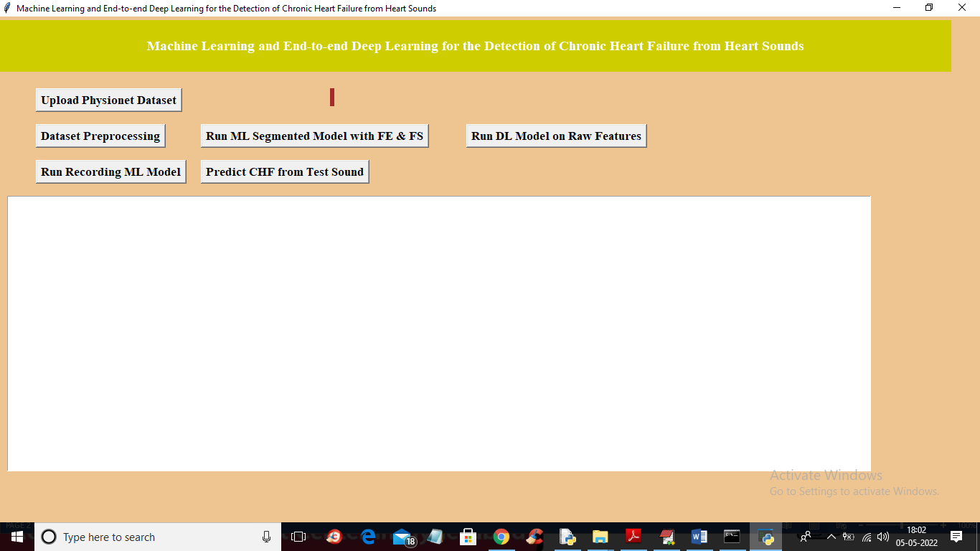

**5.1** To run project double click on ‘run.bat’ file to get below screen

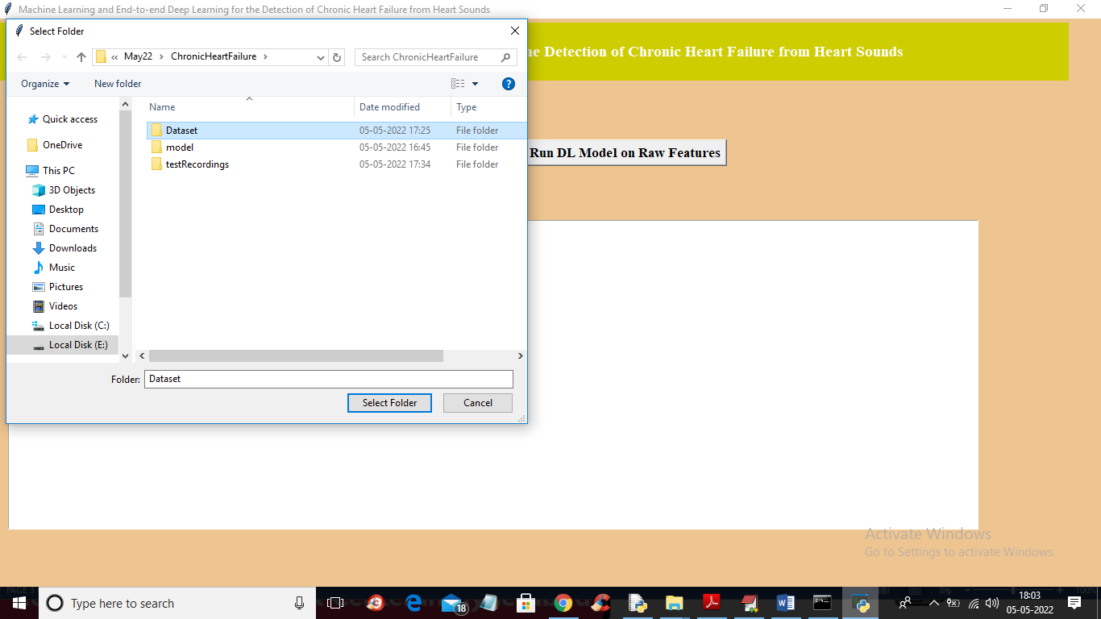

**5.2** In above screen click on ‘Upload Physionet Dataset’ button to upload dataset

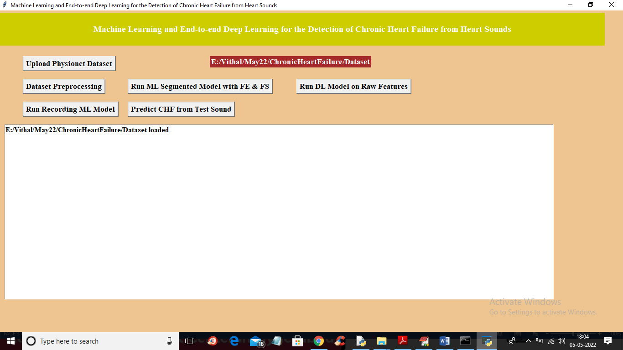

**5.3** In above screen selecting and uploading ‘Dataset’ folder and then click on ‘Select Folder’ button to load dataset and to get below output

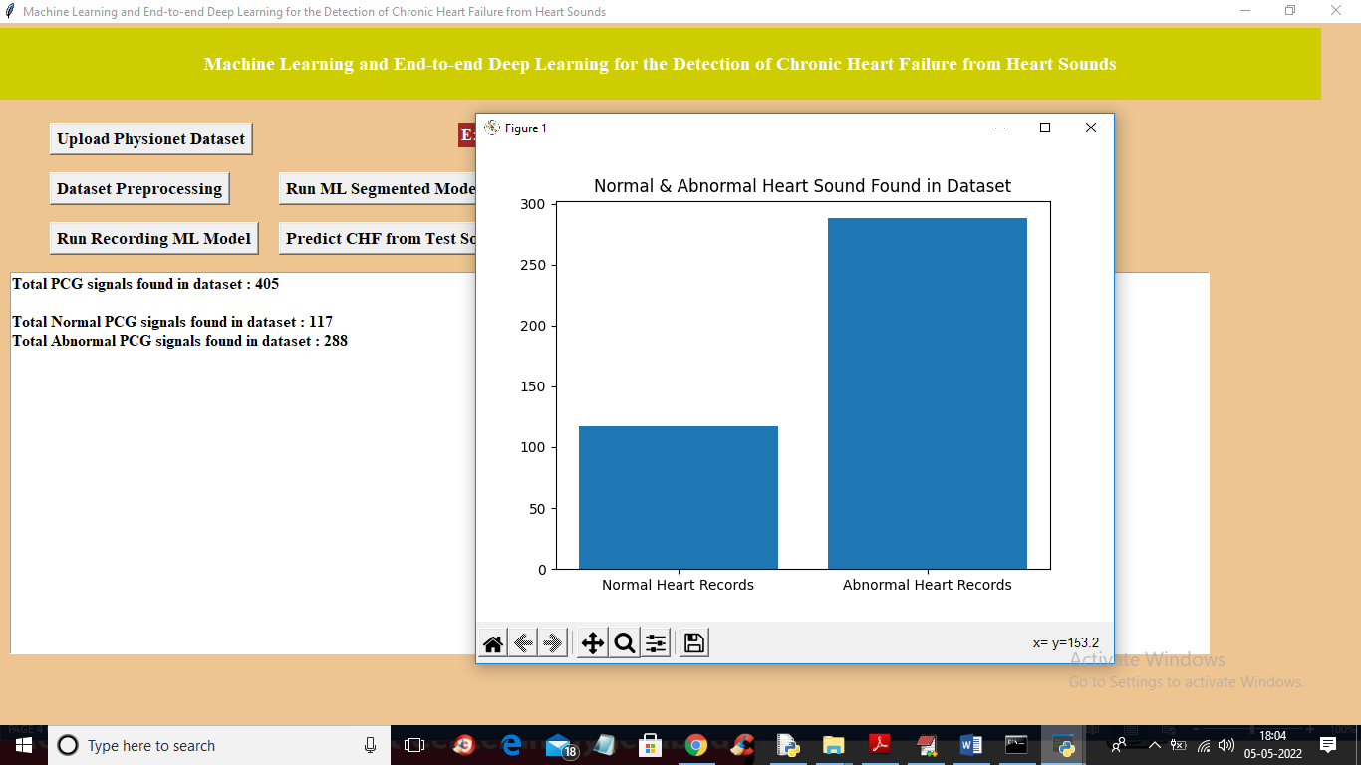

**5.4** In above screen dataset loaded and now click on ‘Dataset Preprocessing’ button to read all dataset file and then extract features from it

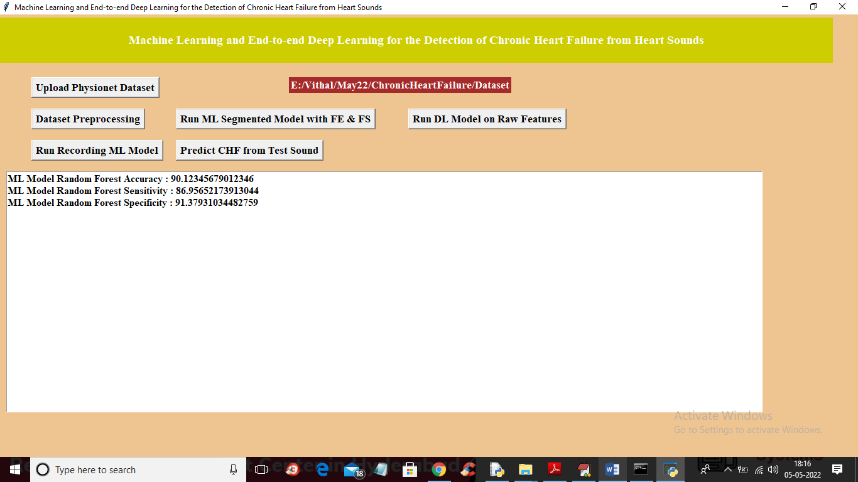

**5.5** In above screen we can see dataset contains 405 heart sound files from 405 different person and 117 are the Normal sound and 288 are abnormal and in graph x-axis represents normal or abnormal and y-axis represents number of persons for normal or abnormal. Now close above graph and then click on ‘Run ML Segmented Model with FE & FS’ button to train Classic ML segmented model on above dataset and get below output

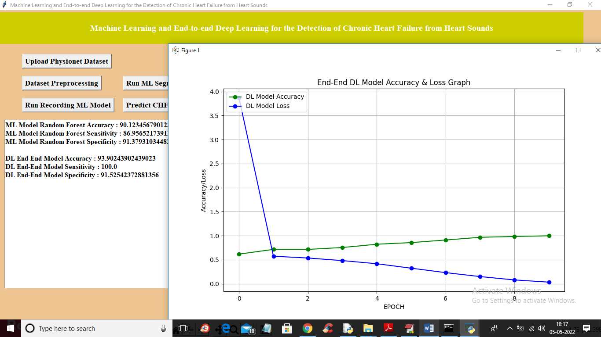

**5.6** In above screen with Classic ML we got 90% accuracy and now click on ‘Run DL Model on Raw Features’ to get below output

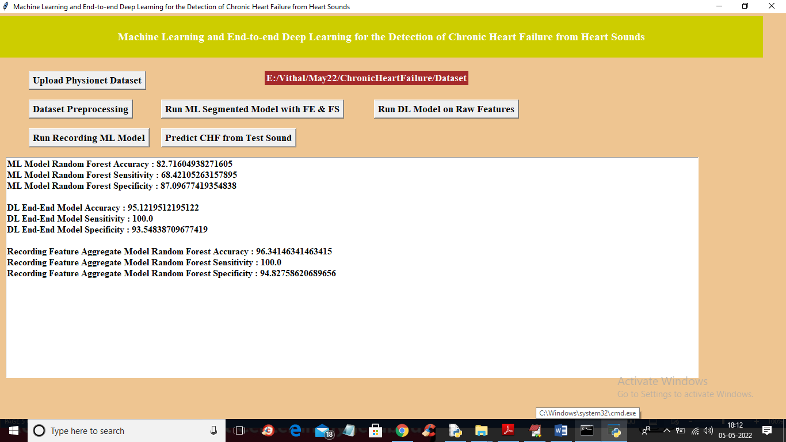

**5.7** In above screen with DL model we got 93% accuracy and in graph x-axis represents epoch or iterations and y-axis represents accuracy or loss values and green line represents accuracy and blue line represents LOSS and we can see with each increasing epoch accuracy got increase and loss got decrease and now close above graph and then click on ‘Run Recording Model’ button to get below output

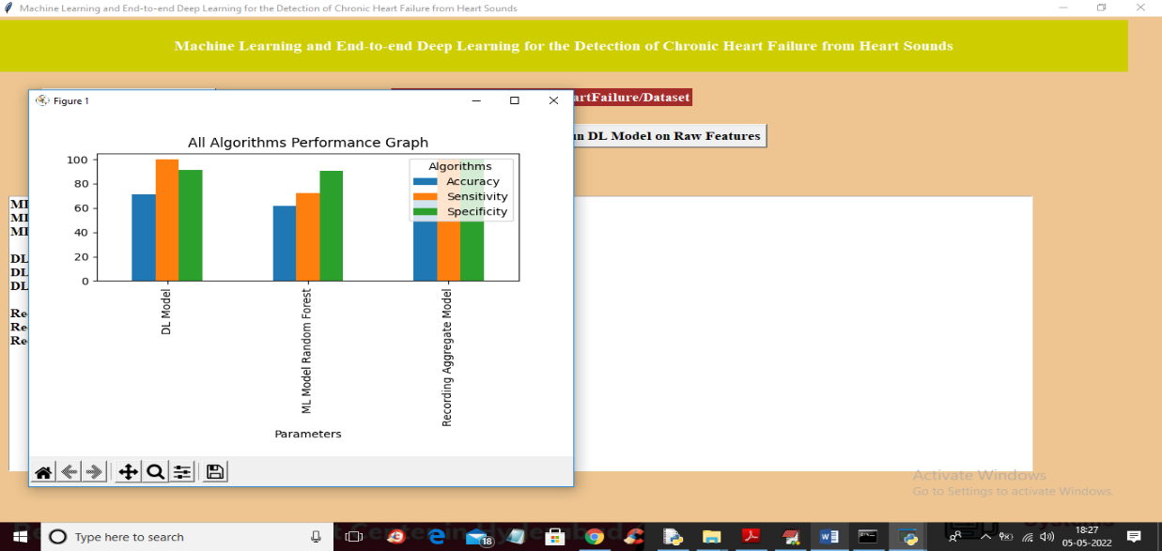

**5.8** In above screen with recording model we got 96% accuracy and we can see all algorithms performance graph in below screen

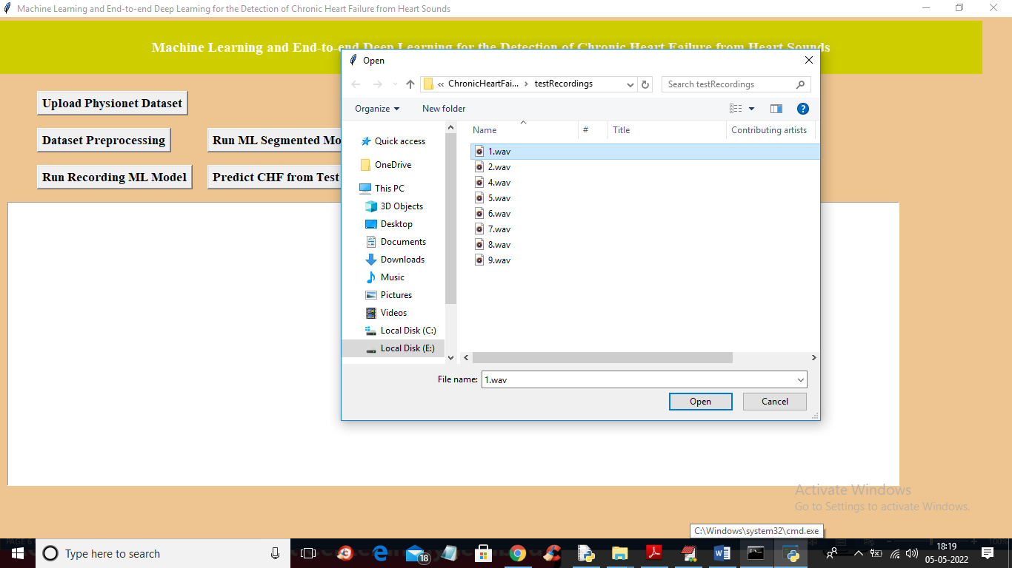

**5.9** In above graph x-axis r epresents algorithm names and y-axis represents accuracy, sensitivity and specificity and in all algorithms Recording model has got high accuracy. Now close above graph and then click on ‘Predict CHF from Test Sound’ button to upload test sound file and get predicted output as Normal or Abnormal

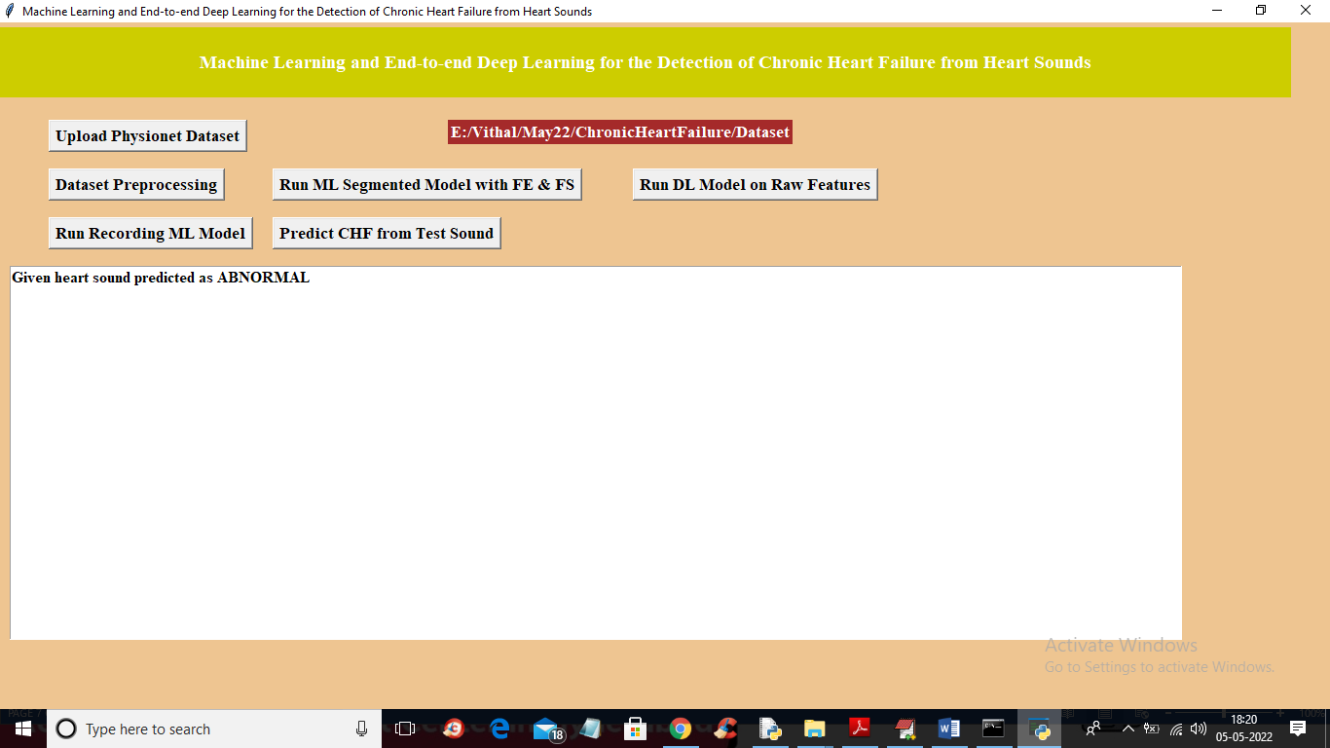

**5.10** In above screen selecting and uploading ‘1.wav’ file and then click on ‘Open’ button to get below output

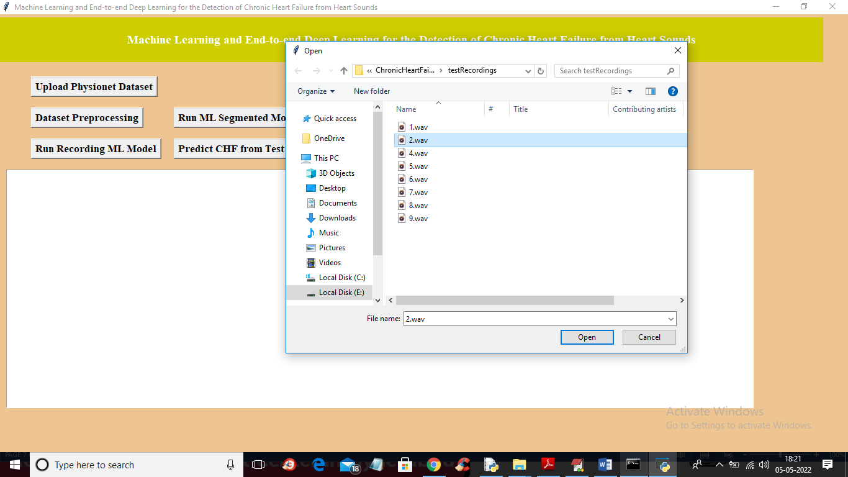

**5.11** In above screen uploaded heart sound file predicted as ABNORMAL and similarly you can upload other files and test

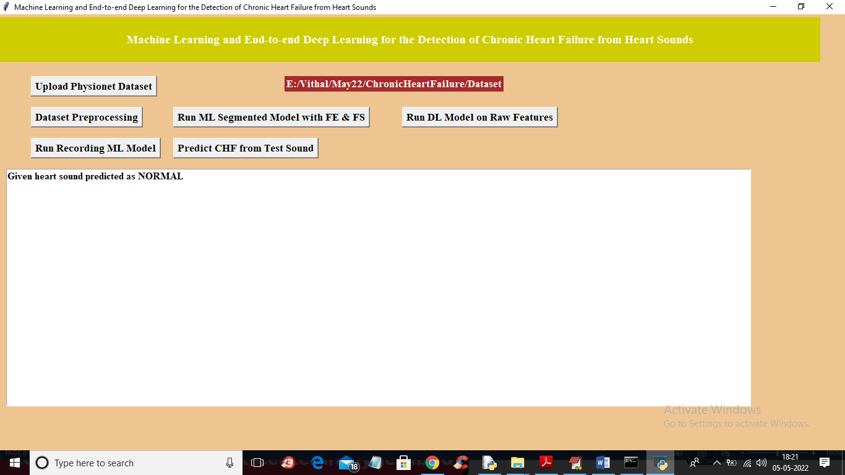

**5.12** For 2.wav’ file below is the output

**6. VALIDATION**

## 

## 6.VALIDATION

Validation is a crucial step to ensure the reliability and effectiveness of the developed model for detecting chronic heart failure from heart sounds. It involves assessing how well the model performs on unseen data and verifying its accuracy and robustness in real-world scenarios.

In this project, k-fold cross-validation and leave-one-subject-out validation techniques were used to evaluate the model's performance. These methods help ensure that the model does not overfit to the training data and can generalize well to new, unseen heart sound recordings.

### INTRODUCTION

First, the heart sound dataset is divided into training and testing sets, typically using an 80-20 split. The training set is used to train the deep learning model, while the testing set evaluates how well the model generalizes to new data. To ensure robust validation, K-fold cross-validation is applied, reducing the chances of overfitting and improving model reliability.

The system's performance is evaluated using key metrics such as accuracy, precision, recall, F1-score, and confusion matrix. The confusion matrix helps identify correct and incorrect classifications, offering insights for performance improvement. The proposed EfficientNet-B7 + BiLSTM model is also compared with other models like EfficientNet-B7 + SVM, showcasing improved accuracy and classification efficiency.

This validation process confirms that the system is both reliable and capable of detecting chronic heart failure from heart sounds effectively in real-world scenarios.

**6.2 TEST CASES**

**TABLE 6.2.1 UPLOADING DATASET**

|  |  |  |  |  |
| --- | --- | --- | --- | --- |
| Test case ID | Test case name | Purpose | Test Case | Output |
|  |  |  | Dataset |
| 1 | User uploads  Dataset. | To use the dataset for prediction | The user uploads the dataset on which the heart sound detection is performed | Dataset successfully loaded |
|  |  |
|  |  |  |
|  |  |  |  |
|  |  |  |  |

**TABLE 6.2.2 CLASSIFICATION**

|  |  |  |  |  |
| --- | --- | --- | --- | --- |
| Test case ID | Test case  name | Purpose | Input | Output |
| 1 | Classification test 1 | To check if the model detects healthy sound | Heart sound from healthy subject | Classified as Normal |
| 2 | Classification test 2 | To check if the model detects CHF condition | Heart sound from CHF patient. | Classified as CHF Detected |

# 7. CONCLUSION & FUTURE ASPECTS

**CONCLUSION & FUTURE ASPECTS**

This project demonstrates the potential of machine learning and deep learning techniques in detecting chronic heart failure (CHF) from heart sounds. By analyzing heart sounds using advanced models, the system can effectively distinguish between healthy and CHF-affected heart conditions. This non-invasive method shows promise for early diagnosis, which is crucial for improving patient outcomes.

### PROJECT CONCLUSION

This project explores the use of machine learning and deep learning techniques for detecting chronic heart failure (CHF) from heart sounds. By leveraging advanced algorithms, the system successfully analyzes and classifies heart sounds, offering a promising alternative to traditional diagnostic methods. The results indicate that heart sound analysis using these technologies can provide an accurate, non-invasive, and cost-effective solution for early detection of CHF.

Through various models, including Convolutional Neural Networks (CNNs), the system shows a strong ability to differentiate between healthy heart sounds and those affected by chronic heart failure. This capability holds significant potential for improving early diagnosis, which is essential for better patient outcomes and timely intervention.

Overall, the project demonstrates the feasibility of integrating machine learning and deep learning into healthcare applications, specifically in the field of cardiovascular diagnostics. While challenges remain, such as dataset variability and model refinement, the project's success lays the foundation for future advancements in automated, real-time heart failure detection.

### 

### 7.2 FUTURE ASPECTS

The future of heart sound analysis for detecting chronic heart failure (CHF) holds significant potential. Enhancing data collection with diverse and extensive datasets will improve model accuracy and generalization. Developing real-time monitoring systems, especially wearable devices, can provide continuous patient feedback for timely interventions. Integrating heart sound analysis with other diagnostic tools, such as ECG or imaging, will lead to more comprehensive diagnoses. Personalizing models for individual patients will improve precision, while further clinical testing and regulatory compliance will ensure practical and ethical adoption. Continued collaboration with healthcare professionals will ensure the system’s clinical relevance and effectiveness, making AI-driven heart sound analysis a valuable tool in early CHF detection and patientcare.

# 8.BIBLIOGRAPHY

1. **BIBLIOGRAPHY**

### REFERENCES

[1] M. Gjoreski et al., “Chronic heart failure detection from heart sounds using a stack of machine-learning classifiers,” in 2017 International Conference on Intelligent Environments (IE). IEEE, 2017, pp. 14-19.

[2] J. Voigt et al., “A reevaluation of the costs of heart failure and its implications for allocation of health resources in the United States,” Clinical cardiology, vol. 37, no. 5, pp. 312-321, 2014.

[3] G. D. Clifford et al., “Classification of normal/abnormal heart sound recordings: the PhysioNet/Computing in Cardiology Challenge 2016,” in 2016 Computing in Cardiology Conference (CinC). IEEE, 2016, pp. 609-612.

[4] X. Jiang, Y. Pang, X. Li, and J. Pan, "Speed up deep neural network based pedestrian detection by sharing features across multi-scale models," Neurocomputing, vol. 185, pp. 163-170, 2016.

[5] A. Krizhevsky, I. Sutskever, and G. E. Hinton, “ImageNet classification with deep convolutional neural networks,” in International Conference on Neural Information Processing Systems, 2012, pp. 1097-1105. [6] C. Szegedy et al., “Inception-v4, inception-ResNet and the impact of residual connections on learning,” in Thirty-First AAAI Conference on Artificial Intelligence, 2017.

[7] T. Young et al., “Recent trends in deep learning based natural language processing,” IEEE Computional intelligence magazine, vol. 13, no. 3, pp. 55-75, 2018.

[8] Y. Bengio et al., “A neural probabilistic language model,” Journal of machine learning research, vol. 3, no. Feb, pp. 1137–1155, 2003.

[9] S. Amiriparian et al., “Recognition of echolalic autistic child vocalisations utilising convolutional recurrent neural networks,” in Interspeech, 2018, pp. 2334-2338.

[10] S. Amiriparian et al., “Bag-of-Deep-Features: Noise-robust deep feature representations for audio analysis,” in International Joint Conference on Neural Networks (IJCNN). IEEE, 2018, pp. 1-7.

### GITHUB LINK

<https://github.com/Sathwikaodela/Detection-of-Chronic-Heart-Failure-From-Heart-Sounds->